

**TRIBHUWAN UNIVERSITY**

**INSTITUTE OF ENGINEERING**

**PASHCHIMANCHAL CAMPUS, POKHARA**

**A PROJECT FINAL REPORT ON**

**Performance Analysis of Placement and Sizing of D-STATCOM in**

**Radial Distribution Network**

**A case study in Begnas Feeder, Lekhnath**

**by**

**Shankar Singh Thakuri**

**A FINAL PROJECT REPORT**

**SUBMITTED TO THE DEPARTMENT OF ELECTRICAL ENGINEERING**

**IN PARTIAL FULLFILLMENT OF THE REQUIREMENTS FOR THE**

**DEGREE OF MASTER OF SCIENCE IN ELECTRICAL ENGINEERING IN**

**DISTRIBUTED GENERATION ENGINEERING**

**DEPARTMENT OF ELECTRICAL ENGINEERING**

**PASCHIMANCHAL CAMPUS**

**POKHARA, NEPAL**

**SEPTEMBER, 2024**

**Performance Analysis of Placement and Sizing of D-STATCOM in Radial Distribution Network: A case study in Begnas Feeder, Lekhnath**

By

Shankar Singh Thakuri

Asst. Prof. Sandeep Dhami

Supervisor

M.SC. Program Coordinator  
Department of Electrical Engineering

Paschimanchal Campus, Tribhuwan University

Submitted to:

**DISTRIBUTED GENERATION ENGINEERING PROGRAM**

**DEPARTMENT OF ELECTRICAL ENGINEERING**

Institute of Engineering, Paschimanchal Campus

Tribhuwan University

Pokhara, Nepal

**ACKNOWLEDGEMENT**

I acknowledge my deep gratitude to my project supervisor Asst. Prof. Sandeep Dhami for the insightful lessons, guidance and inspiration for the completion of project. These efforts have greatly benefited from their encouragement, suggestions, and observations.

Additionally, I would like to express my gratitude to the Pashchimanchal Campus’s faculty members of the Department of Electrical Engineering for their insightful comments and suggestions during the project's many phases.

I would like to express my gratitude to Lekhnath DCS and Pokhara Grid Substation, NEA, for their assistance in supplying the data and clarification needed for the system's modeling, as well as for their advice during the project's implementation

I extend my thanks to my colleagues who provided constant support throughout the study. I take opportunity to thank the authors and publishers of all the sources that helped in every step of this study.

**ABSTARCT**

An electric power system's distribution system connects high-voltage transmission networks to final consumers. This work provides a method for enhancing the voltage profile and lowering power loss in the distribution network by introducing reactive power into the system. Power quality problems such as low voltage and higher loss are typically found in radial distribution networks or systems with long line lengths and heavy loading. The Lekhnath Distribution Center's Begnas Feeder is the subject of this investigation. In this work, the first condition has aimed to find the size of D-STATCOM and its placement by using Variational Technique method and VSI method respectively. Backward and forward load flow analysis is selected to compute all the required parameters in the existing Distribution System. Placement of D-STATCOM has indeed improved voltage profile with active power loss reductions in the 11 KV Begnas Feeder of Lekhnath DC. The results obtained are compared without and with D-STATCOM.

**TABLE OF CONTENTS**

ACKNOWLEDEMENT…………………………………………………………………….III

ABSTRACT…………………………………………………………………………………IV

LIST OF TABLES …………………………………………………………………………VII

LIST OF FIGURES…………………………………………………………………………VII

LIST OF ABBREVIATIONS………………………………………..………………………IX

CHAPTER ONE: INTRODUCTION……………………………………………………… ...1

1.1 Background…………………………………………………………….…………............1

1.2 Problem Statement…….…………………………………………………….…................2

1.3 Objectives….……………………………………………………………………………..2

1.4 Scope and Limitations…………………………………………………………................2

1.5 Report And Organizations…..………………….………………………….……………..3

CHAPTER TWO: LITERATURE REVIEW……………………………………………..….4

2.1 Overview of Distribution Network….…………………………………………………....5

2.2 D-STATCOM Allocation Technique for Loss Reduction ……………..………………...5

2.3 Power flow/Load Flow…………………………………..……………..………………...6

CHAPTER THREE: METHODOLOGY………………………………………………...…..8

3.1 Collection of Data……………….…………………………………………………….….8

3.2 Location of D-STATCOM………………………………………………………………..9

3.2.1 Voltage Stability Index for finding location of D-STATCOM.…………….….…...9

3.2.2. Size calculation by Variational Technique…………….…….………………..........9

CHAPTER FOUR: RESULTS AND DISCUSSIONS……………………………………....12

4.1 Load Flow Analysis of Begnas Feeder at Base Case…………...…………………….….12

4.2 Voltage Stability Calculation..……………………………………………………….…...14

4.3 Load Flow Analysis for Minimum Feeder Active Power Loss……..……………………14

CHAPTER FIVE: CONCLUSIONS AND RECOMMENDATION………………………...17

REFERENCES……………………………………………………………………………….18

APPENDIX-I…………………………………………………………………………………19

APPENDIX-II………………………………………………………………………………..28

# 

# **LIST OF TABLES**

Table A.1: Specification of ACSR Conductor 19 Table A.2: Line Data of Begnas Feeder 19

Table A.3: Load Data of Begnas Feeder 21

Table A.4: VSI data of each Bus 24

Table A.5: Voltage Profile during each step size Penetration of D-STATCOM 26

Table A.6: Total line loss and the corresponding step sizes of D-STATCOM 27

# **LIST OF FIGURES**

Figure 2.1: Radial Distribution Network 5

Figure 2.2: D-STATCOM 6

Figure 3.1: Line Diagram of Begnas Feeder 8

Figure 3.2: Flowchart of Proposed Methodology 11

Figure 4.1 Voltage Profile of Begnas Feeder at Base Case 12

Figure 4.2: Active Power Loss of Begnas Feeder at Base Case 13

Figure 4.3: Reactive Power Loss of Begnas Feeder at Base Case 13

Figure 4.4: VSI for each bus in the feeder 14

Figure 4.5: Total Active Power Loss vs Incremental Sizes of D-STATCOM 15

Figure 4.6: Voltage profile Comparison between base case 15

and after D-STATCOM placement at bus 72 of size 200kvar.

Figure 4.7: Comparative analysis between without and with D-STATCOM 16 Penetration at Bus 72

# **LIST OF ABBREVIATIONS**

ABC Aerial Bundled Conductor

AC Alternating Current

ACSR Aluminum Conductor Reinforced

DC Direct Current

DCS Distributed Control System

DG Distributed Generation

D-STATCOM Distribution Static Compensator

INPS Integrated Nepal Power System

HT High Tensile

NEA Nepal Electricity Authority

PWM Pulse Width Modulation

TAPL Total Active Power Loss

VSI Voltage Stability Index

# **CHAPTER ONE: INTRODUCTION**

# **1.1 Background**

To enhance voltage profiles, lower losses, and conserve energy, distribution systems integrating distributed generation (DG), custom power devices (CPDs), and capacitors must conduct an optimal load flow assessment. Reactive power management, loss reduction, distribution system pricing, and reserve management during peak loads are among the challenges that are addressed by the proper placement of these components. Reactive power demands rise in distribution systems because most loads are reactive. This reactive power can be provided by capacitors, but they may oscillate and their output is dependent on the system voltage. Originally designed for transmission systems, FACTS devices are now utilized in distribution to compensate for reactive power, taking on the role of capacitors or inductors as required.

CPDs that regulate voltage, phase angle, and line impedance effectively and dependably include DVR, D-STATCOM, and UPQC. D-STATCOM is a particularly useful one among them, providing better bus voltage profiles and continuously changing reactive power compensation. A transformer, PWM control technique, inverter modules, ac filter, and dc capacitor are among its primary parts. In both steady-state and dynamic scenarios, D-STATCOM improves voltage control, balancing, and power losses. The effectiveness of D-STATCOM in enhancing voltage profiles and lowering losses in distribution networks has been demonstrated by a number of studies that have suggested methods for appropriate D-STATCOM placement and sizing.

With size estimations made using a variational strategy, this article analyzes D-STATCOM allocation strategies for radial distribution networks using the voltage stability index (VSI) approaches. This technique enhances voltage profiles while reducing line losses. The load flow method consists of three basic steps: figuring out the load current, creating the BIBC matrix, and sweeping the line forward. The bus with the greatest VSI is chosen as the candidate bus after a load flow study is performed. We then apply the variational technique to determine the D-STATCOM size.

# **1.2 Problem Statement**

The electrical power distribution system is an essential part of the infrastructure that ensures the efficient and reliable transport of electricity from generation sources to end consumers. However, maintaining the optimal voltage profile and minimizing losses in the distribution network remain formidable obstacles. These issues could lead to excessive power consumption, increased operational costs, and a deterioration in the reliability and quality of the services.

Research paper's problem statement focuses on solving problems with reactive power management, improving voltage profiles, and lowering power losses in radial distribution systems. It draws attention to the drawbacks of employing capacitors for reactive power adjustment, including their propensity to cause oscillations and reliance on system voltage. As a substitute, the study suggests using D-STATCOM, a static compensator based on a shunt-connected voltage source converter. In order to improve the effectiveness and efficiency of radial distribution networks, the study intends to identify the ideal placement and size of D-STATCOM utilizing voltage stability index (VSI), followed by size calculation through a variational technique.

# **1.3 Objectives**

The objectives of the project are:

* To assess the effectiveness of Voltage Stability Index (VSI) approach for the placement of D-STATCOM in a radial distribution network.
* To determine the corresponding sizes of D-STATCOM using a variational technique.
* To demonstrate the reduction of line losses and improvement in the voltage profile of the distribution network through the placement and sizing of D-STATCOM.

# **1.4 Scope and Limitations**

The project can be applied to assess the initial placement of D-STATCOM in radial system of Begnas Feeder for voltage profile improvement. As the approach involves finding the size of D-STATCOM based on minimum feeder’s total active power loss, the voltage profile improves but does not meet the voltage regulation standards. There is a trade-off one has to pay for either having minimum feeder losses or having voltage profile improvement on par the voltage regulation standards. This limitation is posed by the technique used for sizing and placement of D-STATCOM.

# **1.5 Report Organization**

The first chapter deals with a brief introduction of the project background, problem statement, objectives, scope and limitation and report organization. In the second chapter, the brief of review of different literature during the study regarding the project is presented. The third chapter provides description of the methodology followed in the course of the study in brief**.** In the fourth chapter, the results obtained are presented and discussed in detail. The fifth chapter presents conclusions of the study and recommendations for the further additions that can be done in the study.

**CHAPTER TWO: LITERATURE REVIEW**

The increasing use of capacitors, custom power devices, and distributed generation in distribution systems necessitates a thorough load flow study to determine their optimal placement for improved voltage profile management, loss reduction, and overall energy savings. Reactive power compensation is crucial due to the prevalence of reactive loads like motors and pumps [9]. While capacitors are traditionally used for this purpose, their dependency on system voltage and potential for oscillations pose challenges. FACTS devices, including D-STATCOM, offer a more flexible solution by dynamically adjusting reactive power compensation based on system needs. D-STATCOM, a shunt-connected device, excels in voltage profile improvement and loss reduction. Its advantages include low harmonic distortion, compact size, and continuous operation. This paper focuses on comparing D-STATCOM allocation methods using voltage stability and power loss indices, along with size calculation using a variational technique, to enhance distribution system performance.

Flexible AC Transmission System (FACTS) devices, such as DSTATCOM and UPQC, are increasingly used to address issues in power systems, including low voltage distribution, power quality improvement, and reliability for sensitive loads. These devices offer solutions for reactive power compensation and unbalanced loading under various system conditions. Optimal placement of these devices is crucial for their effectiveness. DSTATCOM, a shunt-connected device, is favored for its advantages like low harmonic distortion, compact size, and continuous operation. Previous research has explored various optimization algorithms for DSTATCOM placement, including immune algorithms, Particle Swarm Optimization (PSO), hybrid heuristic techniques, gravitational search algorithms, firefly algorithms, and modified bat algorithms.

Paper presents a method for allocating D-STATCOM in radial distribution network: voltage stability index (VSI). The size of the D-STATCOM is determined using a variational technique. The load flow method used in this paper involves calculating load current, forming a BIBC matrix, and performing a forward sweep across the line [10]. Initially, a load flow analysis is conducted to calculate line losses and voltage profiles, and the bus with the highest VSI value is chosen as the candidate bus. Subsequently, the size of the D-STATCOM is determined using a variational technique. Finally, a load flow analysis is performed again, this time with the calculated D-STATCOM size at the candidate bus. This method effectively reduces line losses and improves voltage profile.

**2.1 Overview of Distribution Network:**

Distribution systems serve as the conduit between the consumers and the distribution substation. This system provides a range of clients with the safe and dependable transportation of electric energy throughout the service area. generally beginning as a medium-voltage three-phase circuit (between 30 and 60 KV), a distribution system terminates at the customer's location, typically at the meter, at a lower secondary three- or single-phase voltage (generally less than 11 kV). A simple model of radial distribution feeder is as shown in Figure 2.1.

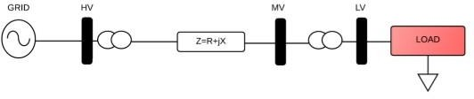

Figure 2.1: Radial Distribution Network

# **2.2 D-STATCOM Allocation Technique for Loss Reduction**

In essence, the D-STATCOM is a bespoke power device. All that is involved is the use of a STATCOM at the distribution level. A custom power device, the D-STATCOM is connected in series with the power supply and is based on an inverter that measures voltage or current. It is linked to the distribution systems in close proximity to the load. A power VSC that is built on high power electronics technologies is the essential part of the D-STATCOM. A VSC, a group of coupling reactors, and a controller make up the three primary components of the D-STATCOM system. A voltage source converter (VSC) coupled to a direct current capacitor (energy storage device) generates a programmable ac voltage source, which is the fundamental working principle of a D-STATCOM installed in a power system.

D-STATCOM is made up of an inverter, a control unit that produces PWM signals for the inverter switches, a coupling inductance L that is used for current filtering and reactive power exchange between D-STATCOM and the power system, and dc link capacitance C that supplies the inverter with dc voltage. Rdc and Rdc stand for the coupling inductance's winding resistance and switching losses in the inverter, respectively. Reactive power exchange between the distribution system and D-STATCOM is accomplished by controlling the inverter output voltage Vi's amplitude. The phasor graphs in Figure 2.2 provide an illustration of the D-STATCOM operation.

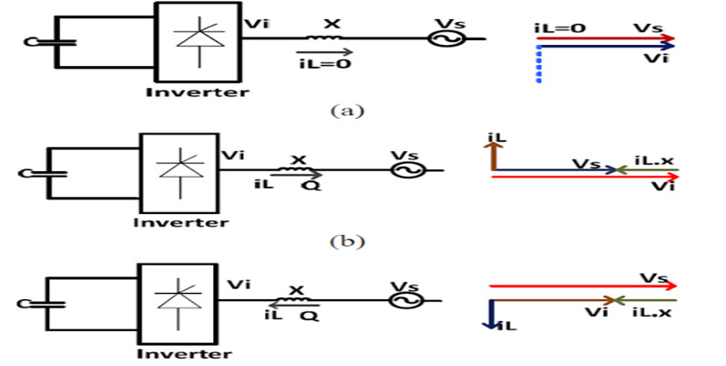

**2.3 Power flow/Load Flow:**

Figure 2.2: D-STATCOM

The computations of load flow can be solved in a variety of ways. To be deemed acceptable, a load flow approach must meet a number of requirements, such as quick speed, low storage requirements, high dependability, and widely acknowledged simplicity and adaptability, power transmission through the grid system from generators to consumers. Load flow analysis is a crucial precondition for power system research. Regarding the radial feeder for load flow, the backward-forward sweep method is employed.

**Calculation of Load Current:**

[1] Load Current  
 total. No. of buses  
 Active power  
 Reactive power  
 Bus Voltage

**Backward Forward Sweep Method:**The relation between load current and branch current can be found by using KCL  
equation. The matrix can Written as:  
[IB]= [BIBC] [IL] [2]  
;IB= Branch Current  
BIBC= Bus injection to Branch Current Matrix  
Forward sweep algorithm is used to calculate the voltage at each bus starting from branches from first layer to last layer. Backward Sweep algorithm is used to calculate the branch current starting from the last layer towards the branches connected to root node.

[3]

Where total no. of Branches.

The power flow is calculated using backward and forward propagation using iterations. The forward sweep will provide the voltage magnitudes whereas the backward propagation provides the power of each branch. The iterative method has fast convergence as compared to conventional methods. It is concluded that the following load flow method is an efficient method for fast convergence tendency in radial distribution networks.

# **CHAPTER THREE: METHODOLOGY**

**3.1 Collection of Data**

Collection of real feeder data (Substation feeder data, voltage level, resistance and reactance of line, daily monthly and annual loading condition, load and its line configuration) of 11 kV Begnas feeder and finding the low voltage point, nodes and their values at different location from DTR installed, HT metering unit, TOD meter installed in substation and industries. The Linedata and Load data are appended in the Appendix I.

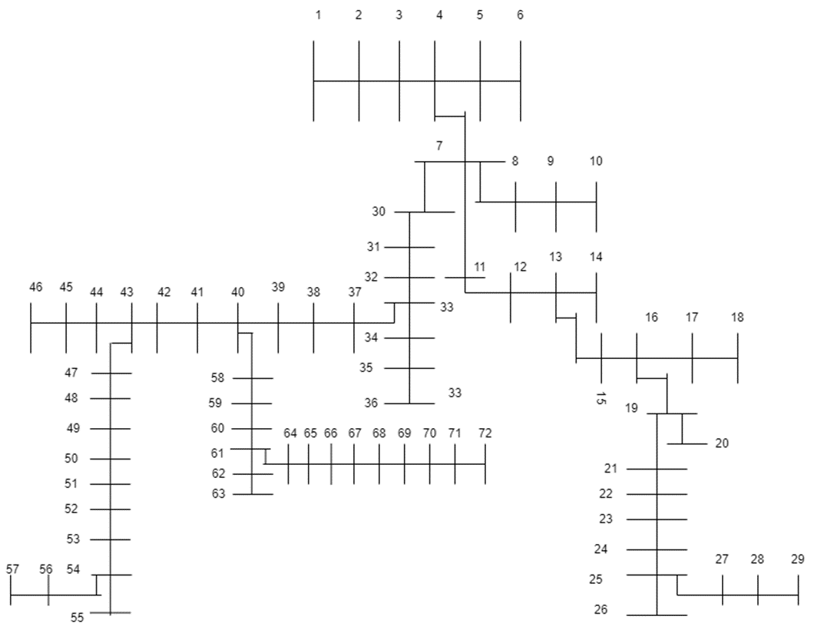

S/S

Figure 3.1: Line Diagram of Begnas Feeder

**3.2 Location of D-STATCOM**

### **3.2.1 Voltage Stability Index for finding location of D-STATCOM**

Location of D-STATCOM is found by calculating the voltage stability index of all the buses. The VSI is calculated from the following equation:

VSI = [4]

Where *Vm* and *Vn* are sending and receiving end voltages respectively; *Im* is the branch current; *Rm* & *Xm* are branch resistance and reactance respectively.

Voltage stability index has been obtained and the bus with highest value of VSI is most unstable and is selected as candidate bus for D-STATCOM. The steps for calculating VSI are described as follows:

* Step 1: Read the radial distribution system line data and bus data.
* Step 2: Perform the load flow to calculate voltages for all the buses and power losses for all the branches.
* Step 3: Calculate VSI for all the buses using equation (3.1).
* Step 4: Select the candidate bus with highest value of stability index.
* Step 5: Stop.

The required code for calculating VSI is appended in Appendix-II.

### **3.2.2 Size calculation by variational technique**

The size of D-STATCOM is calculated using the variational technique. First the base case load flow is made for finding the losses. Then by following steps is used for finding the size of D-STATCOM. Steps for calculating the size of D-STATCOM by variational technique are as follows:

* Step 1: Read the line data and bus data and find the candidate bus for D-STATCOM placement by Voltage Stability Index (VSI).
* Step 2: Place the D-STATCOM at candidate bus with size varying in steps of 50 kvar.
* Step 3: Find the feeder’s total active power losses after placement of D-STATCOM.
* Step 4: Select the size of D-STATCOM which gives minimum losses.
* Step 5: Stop.

The required code for calculating is appended in Appendix-II.

## **Flow Chart of Proposed Methodology**

## 

Figure 3.2: Flowchart of Proposed Methodology

## **CHAPTER FOUR: RESULTS AND DISCUSSIONS**

## **4.1 Load Flow Analysis of Begnas Feeder at BaseCase.**

The Linedata and Load data were obtained and fed to the load flow analysis code written in MATLAB. The code was based on the Backward Forward Sweep Method. The corresponding code is appended in the Appendix. The results of the Load Flow Analysis graphed in Figure 4.1, Figure 4.2 and Figure 4.3 in terms of voltage profile, active power loss and reactive power loss of the feeder respectively.

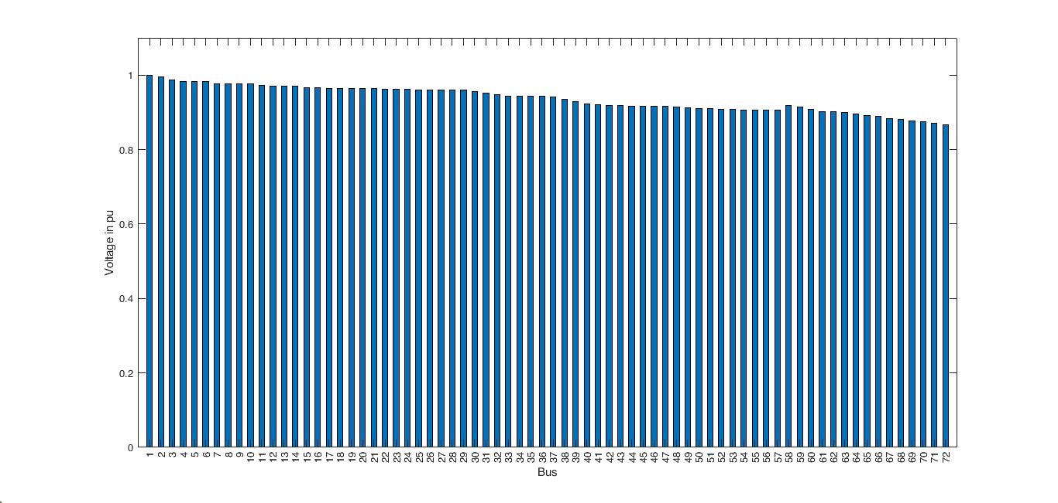

Figure 4.1: Voltage Profile of Begnas Feeder at BaseCase.

Figure 4.1 shows the voltage profile of each bus at the base case scenario. Bus 72 has the lowest voltage with the value of 0.8673 pu, which is justified as the bus 72 is the farthest bus from the substation.

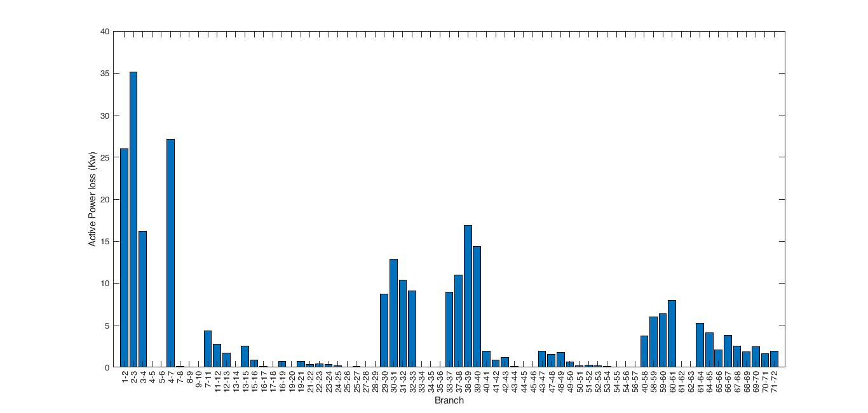

Figure 4.2: Active Power Loss of Begnas Feeder at BaseCase.

Figure 4.2 shows the distribution of active power loss across the branches in the feeder network. The total active power loss during base case scenario is 272.528 kW.

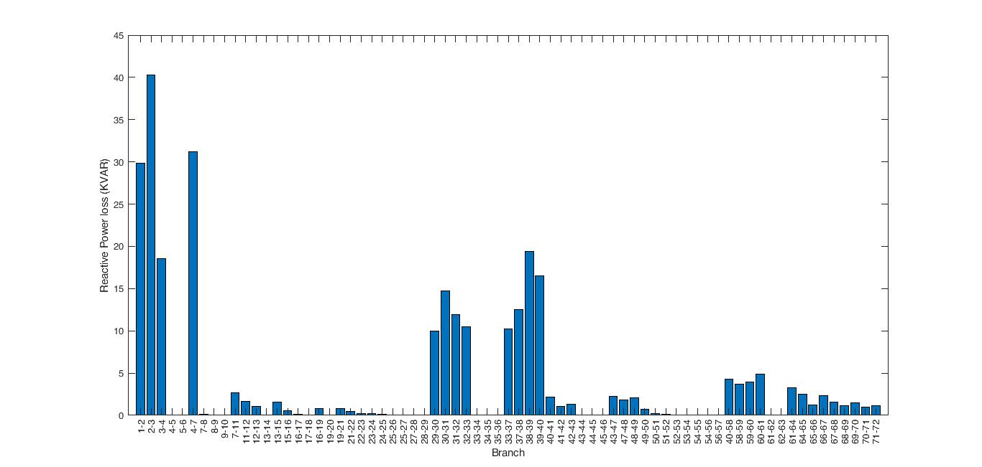

Figure 4.3: Reactive Power Loss of Begnas Feeder at BaseCase.

Figure 4.3 portrays the reactive power loss of each branch in the feeder. The total reactive power loss in the feeder for base case scenario is found to be 280.484 kvar.

## **4.2 Voltage Stability Index Calculation**

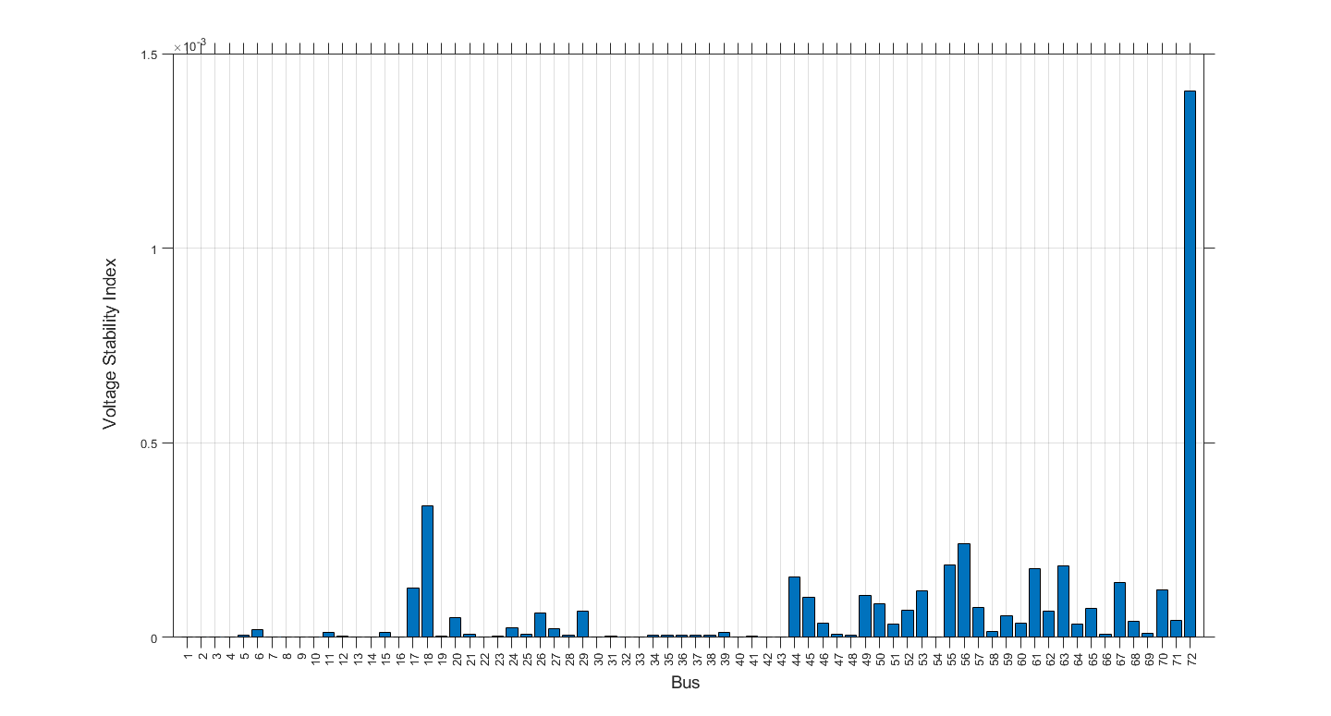Voltage stability Index has been obtained and the bus with highest value of VSI is most unstable and is selected as candidate bus for D-STATCOM. It is found that VSI is highest at bus no 72 in our feeder. Hence the location of D-STATCOM for its placement is Bus 72 by VSI method. Figure 4.4 shows the VSI of all the buses and shows that Bus 72 has the highest among the all. The value obtained for bus 72 was 0.0014. The other is tabulated and appended in the Appendix.

Figure 4.4: VSI for each bus in the Feeder.

## **4.3 Load Flow Analysis for Minimum Feeder Active Power Loss**

To find the size of the D-STATCOM 50kvar of penetration size was chosen and penetrated at Bus 72. Then in steps of 50kvar D-STATCOM was introduced successively and load flow Analysis was performed and total losses were determined for up to 800kvar. Figure 4.5 show the loss vs the size of the D-STATCOM. The graph indicates that as the size increase TAPL decreases and continues for some sizes but once the threshold reaches for the size of D-STATCOM the TAPL increases again. The D-STATCOM size corresponding to final minimum point was chosen as the required size for placement at bus 72.

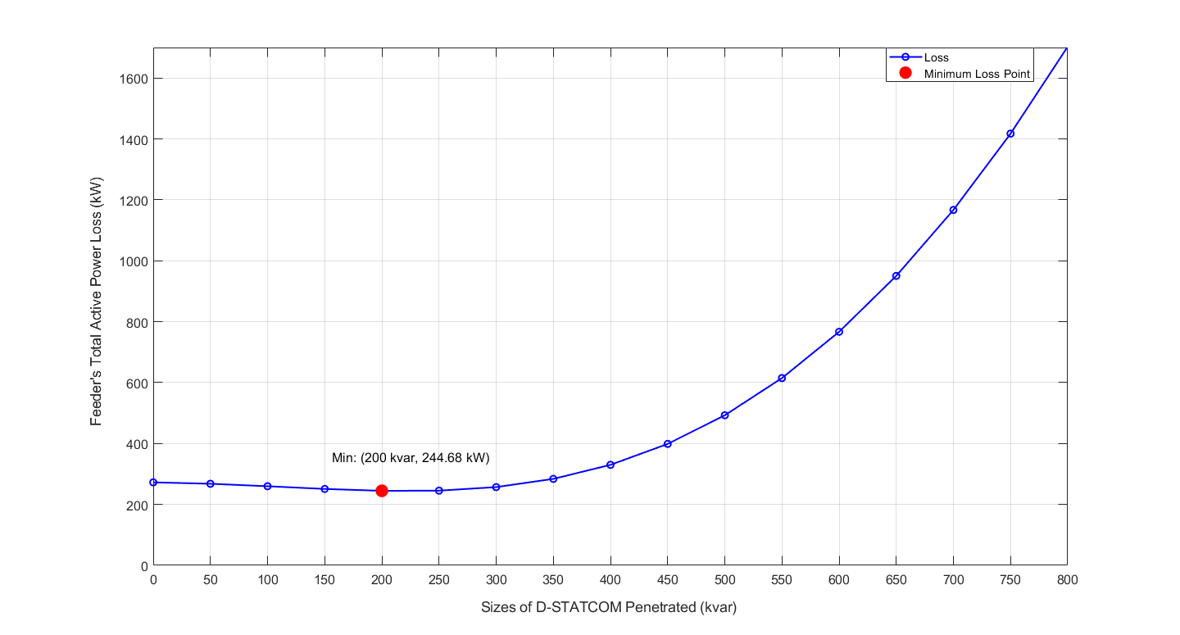

Figure 4.5: Total Active Power Loss vs Incremental Sizes of D-STATCOM

After the selection of size, the voltage profile at the corresponding size was compared to the voltage profile at base case scenario. Figure 4.6 depicts the comparison with a clear show of voltage improvement but not in par with the voltage regulation standards.

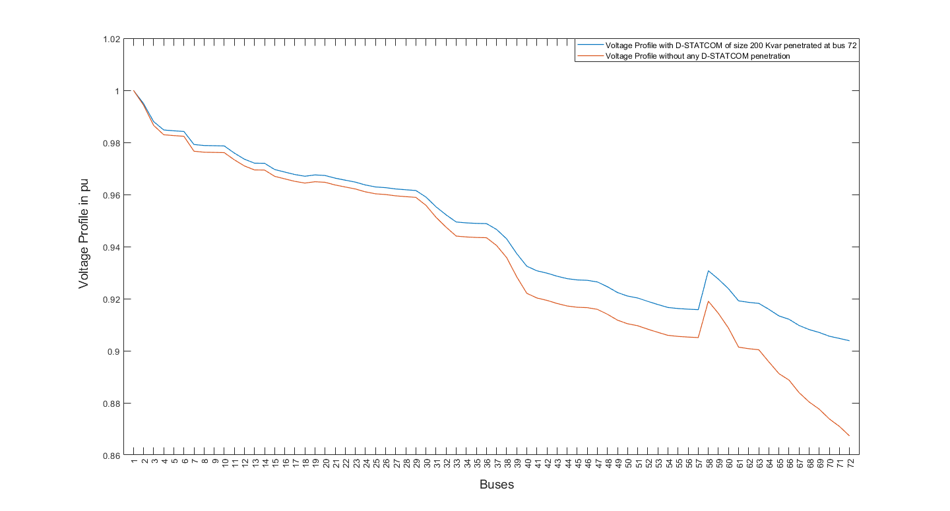

Figure 4.6: Voltage profile Comparison between base case and after D-STATCOM placement at bus 72 of size 200kvar.

Figure 4.7: Comparative analysis between without and with D-STATCOM penetration at Bus 72.

Figure 4.7 depicts the comparison between base case scenario (without D-STACOM penetration) and scenario with D-STATCOM penetration based on voltage and total active power loss. It shows the improvement on both the attributes; voltage and total active power loss after the penetration of D-STATCOM at bus 72.

**CHAPTER FIVE: CONCLUSION AND RECOMMENDATION**

This project focuses on improving the voltage profile of the Begnas Feeder distribution system. The load flow analysis, voltage stability index analysis, and variational techniques were employed in this work. Using this approach 200kvar size of D-STATCOM was placed at Bus-72 for the reactive power compensation and eventually voltage profile improvement. The voltage profile did improve than the base case. The minimum active power loss criterion was the main attribute that selected the size of the D-STATCOM. The corresponding line loss was found to be 244.68kW which is an improvement of 10.21 % than the base case scenario.

Though the voltage profile and line loss did reduce the voltage profile still couldn’t meet the voltage regulation standards which indicates the limitation of this technique. So, it recommended to incorporate the optimization algorithm for finding the size and location as they are corelated parameter for optimal sizing and placement.

**REFERENCES**

[1] Subbarami Reddy1, V Usha Reddy2, "Optimal Placement of D-STATCOM in Radial Distribution System using Fuzzy and Penguins Search Optimization Algorithm," *Innovative research in electrical, electronics, instrumentation and control engineering*, Vols. Vol. 3,, no. Issue 11, pp. 102-106, November 2015.

[2.] Y. T. Gebreyes, "Studies on voltage control of distribution substations using static var compensators," *Addis Ababa institute of technology*, Addis Ababa, 2019.

[3.] T.Taye,"Improvement of Distribution Feeder Loss and Voltage Profile (Case Study:Bella Substation Distribution Feeder)," *Addis Ababa university*, Addis Ababa, Ethiopia, October, 2019“

[4.] S M Suhail Hussain, "An Analytical Approach for Optimal Location of D- STATCOM in Radial Distribution System," *in msubbaramiah, Mahboobnagar*, India., 22 December 2018..

[5]. "Bonyadi, M. R.; Michalewicz, Z. (2017). "Particle swarm optimization for single objective continuous space problems: a review". Evolutionary Computation." (n.d.).

[6]."Optimal placement of DG and DSTATCOM for loss reduction and voltage profile improvement." (n.d.).

[7]."Whale optimization algorithm for optimal sizing of renewable resources for loss reduction in distribution systems." (n.d.).

[8]. "I. Y. Djilani Kobibi, S. Hadjeri, and M. A. Djehaf." *“Study of UPFC Optimal Location Considering Loss Reduction and Improvement of Voltage Stability in Power System* (n.d.). Leonardo Journal of Sciences. Issue.

[9]. Gupta AR, Kumar A (2015) Energy savings using D-STATCOM placement in radial distribution system. Procedia Comput Sci70:558–564.

[10] Gupta, A.R.; Jain, A.; Kumar, A. Optimal D-STATCOM placement in radial distribution system based on power loss index approach. In Proceedings of the 2015 International Conference on Energy, Power and Environment: Towards Sustainable Growth (ICEPE), Shillong, India, 12–13 June 2015; pp. 1–5.

**APPENDIX -I**

Table A.1: Specification of ACSR Conductor

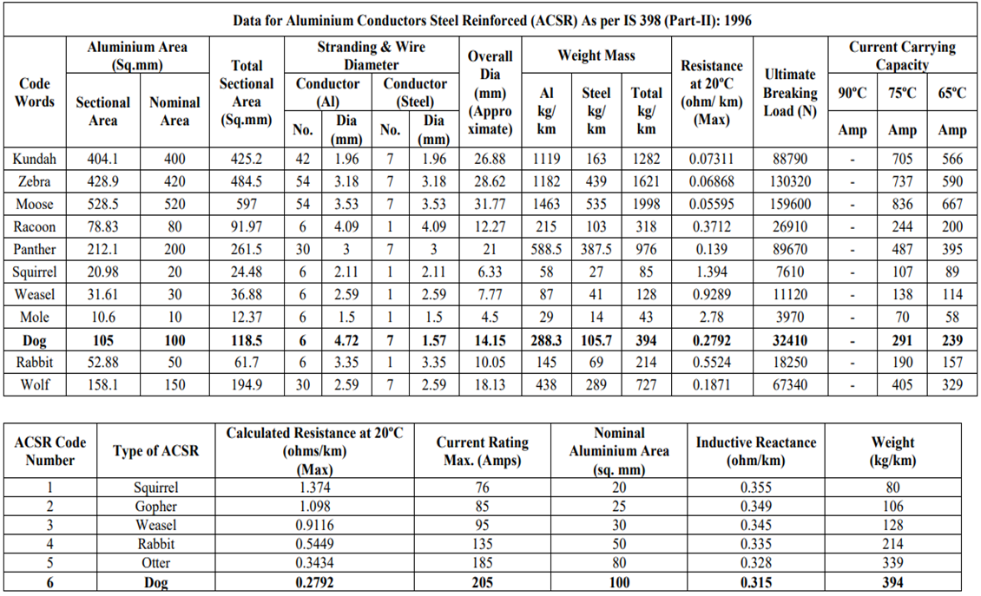

Table A.2: Line Data of Begnas Feeder.

|  |  |  |  |  |  |
| --- | --- | --- | --- | --- | --- |
| **Branch Number** | **From Bus** | **To Bus** | **Length(km)** | **R(ohm)** | **X(ohm)** |
|  |  | 1 |  |  |  |
| 1 | 1 | 2 | 0.324 | 0.088938 | 0.10206 |
| 2 | 2 | 3 | 0.45 | 0.123525 | 0.14175 |
| 3 | 3 | 4 | 0.21 | 0.057645 | 0.06615 |
| 4 | 4 | 5 | 0.529 | 0.288252 | 0.177215 |
| 5 | 5 | 6 | 0.61 | 0.332389 | 0.20435 |
| 6 | 4 | 7 | 0.39 | 0.107055 | 0.12285 |
| 7 | 7 | 8 | 0.32 | 0.08784 | 0.1008 |
| 8 | 8 | 9 | 0.097 | 0.026627 | 0.030555 |
| 9 | 9 | 10 | 0.35 | 0.096075 | 0.11025 |
| 10 | 7 | 11 | 0.43 | 0.234307 | 0.14405 |
| 11 | 11 | 12 | 0.345 | 0.187991 | 0.115575 |
| 12 | 12 | 13 | 0.24 | 0.130776 | 0.0804 |
| 13 | 13 | 14 | 0.116 | 0.063208 | 0.03886 |
| 14 | 13 | 15 | 0.41 | 0.223409 | 0.13735 |
| 15 | 15 | 16 | 0.19 | 0.103531 | 0.06365 |
| 16 | 16 | 17 | 1.12 | 0.610288 | 0.3752 |
| 17 | 17 | 18 | 1.55 | 0.844595 | 0.51925 |
| 18 | 16 | 19 | 0.45 | 0.123525 | 0.14175 |
| 19 | 19 | 20 | 1.04 | 0.566696 | 0.3484 |
| 20 | 19 | 21 | 0.6 | 0.1647 | 0.189 |
| 21 | 21 | 22 | 0.42 | 0.11529 | 0.1323 |
| 22 | 22 | 23 | 0.25 | 0.136225 | 0.08375 |
| 23 | 23 | 24 | 0.65 | 0.354185 | 0.21775 |
| 24 | 24 | 25 | 0.58 | 0.316042 | 0.1943 |
| 25 | 25 | 26 | 0.83 | 0.756628 | 0.28635 |
| 26 | 25 | 27 | 0.58 | 0.528728 | 0.2001 |
| 27 | 27 | 28 | 0.31 | 0.282596 | 0.10695 |
| 28 | 28 | 29 | 0.85 | 0.77486 | 0.29325 |
| 29 | 7 | 30 | 0.29 | 0.079605 | 0.09135 |
| 30 | 30 | 31 | 0.448 | 0.122976 | 0.14112 |
| 31 | 31 | 32 | 0.381 | 0.104585 | 0.120015 |
| 32 | 32 | 33 | 0.35 | 0.096075 | 0.11025 |
| 33 | 33 | 34 | 0.45 | 0.123525 | 0.14175 |
| 34 | 34 | 35 | 0.548 | 0.150426 | 0.17262 |
| 35 | 35 | 36 | 0.71 | 0.194895 | 0.22365 |
| 36 | 33 | 37 | 0.402 | 0.110349 | 0.12663 |
| 37 | 37 | 38 | 0.55 | 0.150975 | 0.17325 |
| 38 | 38 | 39 | 0.9 | 0.24705 | 0.2835 |
| 39 | 39 | 40 | 0.79 | 0.216855 | 0.24885 |
| 40 | 40 | 41 | 0.482 | 0.132309 | 0.15183 |
| 41 | 41 | 42 | 0.263 | 0.072194 | 0.082845 |
| 42 | 42 | 43 | 0.358 | 0.098271 | 0.11277 |
| 43 | 43 | 44 | 1.09 | 0.993644 | 0.37605 |
| 44 | 44 | 45 | 0.95 | 0.86602 | 0.32775 |
| 45 | 45 | 46 | 0.845 | 0.770302 | 0.291525 |
| 46 | 43 | 47 | 0.74 | 0.20313 | 0.2331 |
| 47 | 47 | 48 | 0.65 | 0.178425 | 0.20475 |
| 48 | 48 | 49 | 0.81 | 0.222345 | 0.25515 |
| 49 | 49 | 50 | 0.89 | 0.244305 | 0.28035 |
| 50 | 50 | 51 | 0.936 | 0.256932 | 0.29484 |
| 51 | 51 | 52 | 0.83 | 0.756628 | 0.28635 |
| 52 | 52 | 53 | 0.99 | 0.902484 | 0.34155 |
| 53 | 53 | 54 | 1.3 | 1.18508 | 0.4485 |
| 54 | 54 | 55 | 1.15 | 1.04834 | 0.39675 |
| 55 | 54 | 56 | 1.25 | 1.1395 | 0.43125 |
| 56 | 56 | 57 | 1.08 | 0.984528 | 0.3726 |
| 57 | 40 | 58 | 0.71 | 0.194895 | 0.22365 |
| 58 | 58 | 59 | 0.65 | 0.354185 | 0.21775 |
| 59 | 59 | 60 | 0.9 | 0.49041 | 0.3015 |
| 60 | 60 | 61 | 1.2 | 0.65388 | 0.402 |
| 61 | 61 | 62 | 0.82 | 0.747512 | 0.2829 |
| 62 | 62 | 63 | 1.14 | 1.039224 | 0.3933 |
| 63 | 61 | 64 | 1.09 | 0.593941 | 0.36515 |
| 64 | 64 | 65 | 0.89 | 0.484961 | 0.29815 |
| 65 | 65 | 66 | 0.54 | 0.294246 | 0.1809 |
| 66 | 66 | 67 | 1.1 | 0.59939 | 0.3685 |
| 67 | 67 | 68 | 0.91 | 0.495859 | 0.30485 |
| 68 | 68 | 69 | 0.75 | 0.408675 | 0.25125 |
| 69 | 69 | 70 | 1.04 | 0.566696 | 0.3484 |
| 70 | 70 | 71 | 0.92 | 0.501308 | 0.3082 |
| 71 | 71 | 72 | 1.26 | 0.686574 | 0.4221 |

Table A.3: Load Data of the Begnas Feeder

|  |  |  |  |  |
| --- | --- | --- | --- | --- |
| **Branch Number** | **From Bus** | **To Bus** | **PL (KW)** | **QL(KVAR)** |
|  |  | 1 | 0 | 0 |
| 1 | 1 | 2 | 75.2 | 27.288 |
| 2 | 2 | 3 | 37.6 | 13.644 |
| 3 | 3 | 4 | 150.4 | 54.576 |
| 4 | 4 | 5 | 37.6 | 13.644 |
| 5 | 5 | 6 | 75.2 | 27.288 |
| 6 | 4 | 7 | 0 | 0 |
| 7 | 7 | 8 | 150.4 | 54.576 |
| 8 | 8 | 9 | 150.4 | 54.576 |
| 9 | 9 | 10 | 75.2 | 27.288 |
| 10 | 7 | 11 | 150.4 | 54.576 |
| 11 | 11 | 12 | 75.2 | 27.288 |
| 12 | 12 | 13 | 0 | 0 |
| 13 | 13 | 14 | 75.2 | 27.288 |
| 14 | 13 | 15 | 150.4 | 54.576 |
| 15 | 15 | 16 | 0 | 0 |
| 16 | 16 | 17 | 75.2 | 27.288 |
| 17 | 17 | 18 | 75.2 | 27.288 |
| 18 | 16 | 19 | 75.2 | 27.288 |
| 19 | 19 | 20 | 37.6 | 13.644 |
| 20 | 19 | 21 | 75.2 | 27.288 |
| 21 | 21 | 22 | 37.6 | 13.644 |
| 22 | 22 | 23 | 225.6 | 81.864 |
| 23 | 23 | 24 | 75.2 | 27.288 |
| 24 | 24 | 25 | 37.6 | 13.644 |
| 25 | 25 | 26 | 37.6 | 13.644 |
| 26 | 25 | 27 | 37.6 | 13.644 |
| 27 | 27 | 28 | 75.2 | 27.288 |
| 28 | 28 | 29 | 37.6 | 13.644 |
| 29 | 7 | 30 | 75.2 | 27.288 |
| 30 | 30 | 31 | 75.2 | 27.288 |
| 31 | 31 | 32 | 75.2 | 27.288 |
| 32 | 32 | 33 | 0 | 0 |
| 33 | 33 | 34 | 112.8 | 40.932 |
| 34 | 34 | 35 | 75.2 | 27.288 |
| 35 | 35 | 36 | 37.6 | 13.644 |
| 36 | 33 | 37 | 150.4 | 54.576 |
| 37 | 37 | 38 | 75.2 | 27.288 |
| 38 | 38 | 39 | 37.6 | 13.644 |
| 39 | 39 | 40 | 0 | 0 |
| 40 | 40 | 41 | 75.2 | 27.288 |
| 41 | 41 | 42 | 37.6 | 13.644 |
| 42 | 42 | 43 | 0 | 0 |
| 43 | 43 | 44 | 37.6 | 13.644 |
| 44 | 44 | 45 | 37.6 | 13.644 |
| 45 | 45 | 46 | 18.8 | 6.822 |
| 46 | 43 | 47 | 37.6 | 13.644 |
| 47 | 47 | 48 | 37.6 | 13.644 |
| 48 | 48 | 49 | 376 | 136.44 |
| 49 | 49 | 50 | 225.6 | 81.864 |
| 50 | 50 | 51 | 75.2 | 27.288 |
| 51 | 51 | 52 | 37.6 | 13.644 |
| 52 | 52 | 53 | 37.6 | 13.644 |
| 53 | 53 | 54 | 0 | 0 |
| 54 | 54 | 55 | 37.6 | 13.644 |
| 55 | 54 | 56 | 37.6 | 13.644 |
| 56 | 56 | 57 | 18.8 | 6.822 |
| 57 | 40 | 58 | 75.2 | 27.288 |
| 58 | 58 | 59 | 150.4 | 54.576 |
| 59 | 59 | 60 | 37.6 | 13.644 |
| 60 | 60 | 61 | 75.2 | 27.288 |
| 61 | 61 | 62 | 37.6 | 13.644 |
| 62 | 62 | 63 | 37.6 | 13.644 |
| 63 | 61 | 64 | 18.8 | 6.822 |
| 64 | 64 | 65 | 75.2 | 27.288 |
| 65 | 65 | 66 | 37.6 | 13.644 |
| 66 | 66 | 67 | 75.2 | 27.288 |
| 67 | 67 | 68 | 37.6 | 13.644 |
| 68 | 68 | 69 | 18.8 | 6.822 |
| 69 | 69 | 70 | 75.2 | 27.288 |
| 70 | 70 | 71 | 37.6 | 13.644 |
| 71 | 71 | 72 | 473.76 | 171.9144 |

Table A.4: VSI Data of each Bus

|  |  |
| --- | --- |
| Bus | VSI |
| 1 | 0 |
| 2 | 1.15E-06 |
| 3 | 1.56E-06 |
| 4 | 6.45E-07 |
| 5 | 6.47E-06 |
| 6 | 1.99E-05 |
| 7 | 0 |
| 8 | 2.33E-06 |
| 9 | 6.49E-08 |
| 10 | 1.52E-06 |
| 11 | 1.41E-05 |
| 12 | 3.66E-06 |
| 13 | 0 |
| 14 | 1.40E-07 |
| 15 | 1.24E-05 |
| 16 | 0 |
| 17 | 0.00012714 |
| 18 | 0.000337661 |
| 19 | 3.32E-06 |
| 20 | 5.10E-05 |
| 21 | 7.86E-06 |
| 22 | 1.35E-06 |
| 23 | 4.27E-06 |
| 24 | 2.51E-05 |
| 25 | 8.92E-06 |
| 26 | 6.26E-05 |
| 27 | 2.14E-05 |
| 28 | 6.53E-06 |
| 29 | 6.74E-05 |
| 30 | 8.99E-07 |
| 31 | 3.33E-06 |
| 32 | 2.07E-06 |
| 33 | 0 |
| 34 | 5.20E-06 |
| 35 | 6.26E-06 |
| 36 | 6.81E-06 |
| 37 | 4.95E-06 |
| 38 | 6.37E-06 |
| 39 | 1.41E-05 |
| 40 | 0 |
| 41 | 4.46E-06 |
| 42 | 3.64E-07 |
| 43 | 0 |
| 44 | 0.000155115 |
| 45 | 0.000102907 |
| 46 | 3.62E-05 |
| 47 | 8.17E-06 |
| 48 | 5.55E-06 |
| 49 | 0.000107769 |
| 50 | 8.62E-05 |
| 51 | 3.35E-05 |
| 52 | 6.98E-05 |
| 53 | 0.000118757 |
| 54 | 0 |
| 55 | 0.000187118 |
| 56 | 0.000240515 |
| 57 | 7.76E-05 |
| 58 | 1.48E-05 |
| 59 | 5.49E-05 |
| 60 | 3.68E-05 |
| 61 | 0.000176731 |
| 62 | 6.85E-05 |
| 63 | 0.000184357 |
| 64 | 3.37E-05 |
| 65 | 7.42E-05 |
| 66 | 8.37E-06 |
| 67 | 0.000142306 |
| 68 | 4.07E-05 |
| 69 | 1.15E-05 |
| 70 | 0.00012335 |
| 71 | 4.31E-05 |
| 72 | 0.001402992 |

Table A.5: Voltage Profile during each step size Penetration



Table A.6: Total Line Loss and the corresponding step sizes of D-STATCOM

|  |  |
| --- | --- |
| Steps(kvar) | Active Power Loss(kW) |
| 0 | 272.529 |
| 50 | 267.822 |
| 100 | 259.754 |
| 150 | 250.875 |
| 200 | 244.682 |
| 250 | 245.264 |
| 300 | 256.930 |
| 350 | 283.880 |
| 400 | 329.982 |
| 450 | 398.639 |
| 500 | 492.765 |
| 550 | 614.799 |
| 600 | 766.762 |
| 650 | 950.315 |
| 700 | 1166.823 |
| 750 | 1417.404 |
| 800 | 1702.981 |

**APPENDIX -II**

The code referenced in the project is given below.

clc

clear all;

m=load('loaddata.m');

l=load('linedata.m');

br=length(l);

numberofBuses=length(m);

[voltagesmag,active,reactive,res,ind]=indLoadFlow(m,l);

[penetrationBus, vsi]= findTargetBus(voltagesmag,active,reactive,res,ind)

[loss,size,volt]=variation(penetrationBus,m,l)

[minValue,idx]=min(loss)

bus=1:1:72;

% % to plot the VSI of each bus

bar(bus,vsi)

xlim([0 72])

xlabel('Bus')

ylabel('Voltage Stability Index')

xticks(bus);

xlim([0 73])

%to plot the voltage profile at each penetration of D -STATCOM

voltbase=volt(:,1)

voltaData=volt(:,idx);

plot(bus,voltaData)

xlim([0 73])

xticks(bus);

xlabel('Buses')

ylabel('Voltage Profile in pu')

hold on

plot(bus,voltbase)

%% This code find the minimum loss point and marks the point in the graph and plot it

[min_loss, min_index] = min(loss);

ylab=0:200:1600

%Create the plot

figure;

plot(size, loss, 'b-o', 'LineWidth', 1.5, 'MarkerSize', 6);

xticks(size)

yticks(ylab)

ylim([0 1700])

hold on;

plot(size(min_index), min_loss, 'ro', 'MarkerSize', 8, 'MarkerFaceColor', 'r');

xlabel('Sizes of D-STATCOM Penetrated');

ylabel('Feeder Total Active Power Loss (kW)');

legend('Loss', 'Minimum Loss Point', 'Location', 'northeast');

grid on;

text(size(min_index), min_loss, sprintf(' Min: (%.0f, %.2f)', size(min_index), min_loss), ...

'VerticalAlignment', 'bottom', 'HorizontalAlignment', 'left');

set(gca, 'FontSize', 12);

set(gcf, 'Color', 'white');

function [penBus,vsi] = findTargetBus(voltagesmag,active,reactive,res,ind)

% % This bit of code calculates the voltage stability index for each bus

p=active;

q=reactive;

voltage=abs(voltagesmag);

vsi1=[];

for ho = 1: 71

zeq= abs(res(ho)+1i*ind(ho));

vsi1(1,end+1)= (4*(zeq)^2*q(ho+1))/(voltage(ho))^2*ind(ho);

end

[~,indices]=sort(vsi1);

penBus=indices(end)+1;

vsi1=[0,vsi1];

vsi=vsi1';

end

% this determines the minimum size of D-statcom without considering the

% Ploss

function bestSize= profile(volt)

for i=1:33

volt1=volt(:,i);

for k= 1:length(volt1)

if volt1(k)<0.95

logic=0;

break

else

logic=1;

end

end

if logic==1

bestSize=i

break;

end

end

end

% D_statcom Placement

function [loss,size,volt]= variation(penetrationBus,m,l)

steps=0:50:800

loss=[];

voltage1=[];

for i =1:length(steps)

data=m(penetrationBus,3)-steps(i);

m(penetrationBus,3)= data;

[voltage,~,~,~,~,losses]=indLoadFlow(m,l);

voltage1=[voltage1,voltage];

loss=[loss,sum(losses)];

end

loss=loss';

size=steps;

volt=voltage1;

% size=optSize;

end

% Basic load flow Function

function [voltageModify,powBranch1,qowBranch1,res,ind,losses] = indLoadFlow(m,l)

format short;

br=length(l);

no=length(m);

f=0;

d=0;

MVAb=100;

KVb=11;

Zb=(KVb^2)/MVAb;

Pg = zeros(no,1);

Pg1 = zeros(no,1);

for i=1:br

R(i,1)=(l(i,4))/Zb;

X(i,1)=(l(i,5))/Zb;

end

for i=1:no

P(i,1)=(m(i,2)/(1000*MVAb));

Q(i,1)=(m(i,3)/(1000*MVAb));

end

R;

X;

res=R;

ind=X;

powBranch1=P;

qowBranch1=Q;

C=zeros(br,no);

for i=1:br

a=l(i,2);

b=l(i,3);

for j=1:no

if a==j

C(i,j)=-1;

end

if b==j

C(i,j)=1;

end

end

end

C;

e=1;

for i=1:no

d=0;

for j=1:br

if C(j,i)==-1

d=1;

end

end

if d==0

endnode(e,1)=i;

e=e+1;

end

end

endnode;

h=length(endnode);

for j=1:h

e=2;

f=endnode(j,1);

% while (f~=1)

for s=1:no

if (f~=1)

k=1;

for i=1:br

if ((C(i,f)==1)&&(k==1))

f=i;

k=2;

end

end

k=1;

for i=1:no

if ((C(f,i)==-1)&&(k==1));

f=i;

g(j,e)=i;

e=e+1;

k=3;

end

end

end

end

end

for i=1:h

g(i,1)=endnode(i,1);

end

g;

w=length(g(1,:));

for i=1:h

j=1;

for k=1:no

for t=1:w

if g(i,t)==k

g(i,t)=g(i,j);

g(i,j)=k;

j=j+1;

end

end

end

end

g;

for k=1:br

e=1;

for i=1:h

for j=1:w-1

if (g(i,j)==k)

if g(i,j+1)~=0

adjb(k,e)=g(i,j+1);

e=e+1;

else

adjb(k,1)=0;

end

end

end

end

end

adjb;

for i=1:br-1

for j=h:-1:1

for k=j:-1:2

if adjb(i,j)==adjb(i,k-1)

adjb(i,j)=0;

end

end

end

end

adjb;

x=length(adjb(:,1));

ab=length(adjb(1,:));

for i=1:x

for j=1:ab

if adjb(i,j)==0 && j~=ab

if adjb(i,j+1)~=0

adjb(i,j)=adjb(i,j+1);

adjb(i,j+1)=0;

end

end

if adjb(i,j)~=0

adjb(i,j)=adjb(i,j)-1;

end

end

end

adjb;

for i=1:x-1

for j=1:ab

adjcb(i,j)=adjb(i+1,j);

end

end

b=length(adjcb);

% voltage current program

for i=1:no

vb(i,1)=1;

end

for s=1:10

for i=1:no

nlc(i,1)=conj(complex(P(i,1),Q(i,1)))/(vb(i,1));

end

nlc;

for i=1:br

Ibr(i,1)=nlc(i+1,1);

end

Ibr;

xy=length(adjcb(1,:));

for i=br-1:-1:1

for k=1:xy

if adjcb(i,k)~=0

u=adjcb(i,k);

Ibr(i,1)=Ibr(i,1)+Ibr(u,1);

end

end

end

Ibr;

for i=2:no

g=0;

for a=1:b

if xy>1

if adjcb(a,2)==i-1

u=adjcb(a,1);

vb(i,1)=((vb(u,1))-((Ibr(i-1,1))*(complex((R(i-1,1)),X(i-1,1)))));

g=1;

end

if adjcb(a,3)==i-1

u=adjcb(a,1);

vb(i,1)=((vb(u,1))-((Ibr(i-1,1))*(complex((R(i-1,1)),X(i-1,1)))));

g=1;

end

end

end

if g==0

vb(i,1)=((vb(i-1,1))-((Ibr(i-1,1))*(complex((R(i-1,1)),X(i-1,1)))));

end

end

s=s+1;

end

nlc;

Ibr;

iBranch=Ibr;

bcurrent=iBranch;

vb;

vbp=[abs(vb)];

for i=1:no

va(i,2)=vbp(i,1);

end

for i=1:no

va(i,1)=i;

P1(i) = P(i);

Q1(i) = Q(i);

end

va;

Ibrp=[abs(Ibr)];

PL(1,1)=0;

QL(1,1)=0;

powBranch=[];

qowBranch=[];

% losses at base case

for f=1:br

Pl(f,1)=(Ibrp(f,1)^2)*R(f,1);

Ql(f,1)=X(f,1)*(Ibrp(f,1)^2);

powBranch(1,end+1)=Pl(f);

qowBranch(1,end+1)=Ql(f);

PL(1,1)=PL(1,1)+Pl(f,1);

QL(1,1)=QL(1,1)+Ql(f,1);

end

Plosskw=(Pl)*100000;

Qlosskw=(Ql)*100000;

PL=(PL)*100000;

QL=(QL)*100000;

losses=Plosskw;

voltage = vbp(:,1);

v_mag = va(:,2);

voltageModify=v_mag;

% for plotting bar and formatting the graph

bus=1:1:29;

bus=bus.';

bar(bus,voltage,0.2)

xticks(bus);

xlabel('Bus');

ylabel('Voltage in pu');

ylim([0 1.1]);

% for plotting bar and formatting the graph

bus=1:1:no;

bus=bus.';

pBus= bus(2:end);

%subplot(2,1,1)

bar(pBus,Plosskw);

xticks(pBus);

xticklabels({'1-2','2-3','3-4','4-5','5-6','6-7','7-8','8-9','9-10','10-11','11-12','12-13','13-14','2-15','5-16','16-17','8-18','18-19','19-20','20-21','11-22','22-23','22-24','24-25','12-26','26-27','26-28','28-29'})

xlabel('Branch');

ylabel('Active Power loss (Kw)');

%ylim([0 1.1]);

%subplot(2,1,2)

figure()

bar(bus,voltage,0.5);

xticks(bus);

xlabel('Bus');

ylabel('Voltage in pu');

ylim([0 1.1]);

figure()

bar(pBus,Qlosskw);

xticks(pBus);

xticklabels({'1-2','2-3','3-4','4-5','5-6','6-7','7-8','8-9','9-10','10-11','11-12','12-13','13-14','2-15','5-16','16-17','8-18','18-19','19-20','20-21','11-22','22-23','22-24','24-25','12-26','26-27','26-28','28-29'})

xlabel('Branch');

ylabel('Reactive Power loss (KVAR);

end